We invite all Addams' 7th & 8th grade Japanese Dual Language students to join us for a
JAPANESE COMPANY TOUR OF:
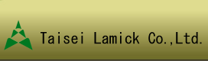 Taisei Lamick USA, Inc. in Elk Grove Village
Leading Japanese liquid packaging manufacturer that packages soy sauce, ketchup, mustard, etc. A company tour and machine demonstration will be conducted in Japanese.
See company website for further info.: http://www.taiseilamick.com
Purpose: This tour is a great opportunity to introduce our dual language students to local businesses and help develop a relationship.
Date: TBD
Time: 11:30am to 1:00pm (Lunch at Kurumaya Restaurant in EGV)/1:30pm to 2:30pm (Tour)
Cost: Tour is free, but lunch is $8.95 to $11.15 plus tax
Details: We will meet at 11:10am at Margaret Mead Jr. High Parking Lot & carpool over together. If you can drive please let us know below. We will return to Mead Jr. High about 3:00pm.
SPACE IS LIMITED- only 10 spots available & FIRST COME FIRST SERVE! Please dress business casual (nice jeans ok).
RSVP: Please complete the form below and return to Robi or Mia Vollkommer BY Wed., April 27th!!!!!! OR email to: gvollkom@aol.com
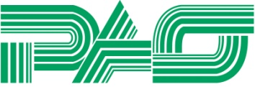 Co-Organized by Pacific Advisory Service & Schaumburg Oyanokai 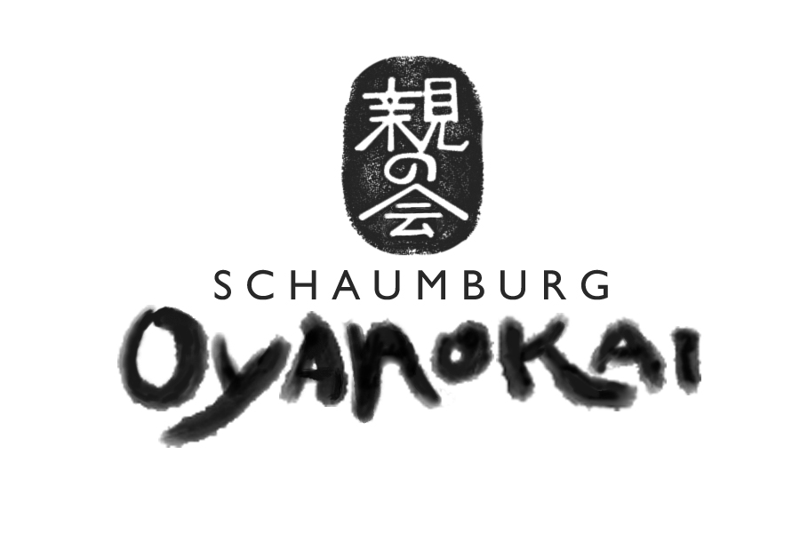 Pacific Advisory Service is a Chicago-based recruiting firm established in 1988 for the purpose of promoting business relations between the United States and the Asia-Pacific region. Schaumburg Oyanokai is a not-for-profit organization that offers Japanese educational and cultural opportunities to the Japanese dual language Community. Schaumburg Oyanokai is not affiliated with School District 54 nor the PTA.
-----------------------------------------------------------------------------------------------------
Participant Name:
Emergency Contact/PARENT NAME:
Tel. Email: please print clearly please print clearly
___________ I'd like to help and come too! I can drive _________ (#) students in my car.

